**Major Port Traffic and Capacity Analytics using IBM Cognos Analytics**

**Submitted by**

**JIGYASA BISHT**

**19BAI10025**

**Steps to be followed with respective screenshots of the tasks**

**>> Create And Login to IBM Account**

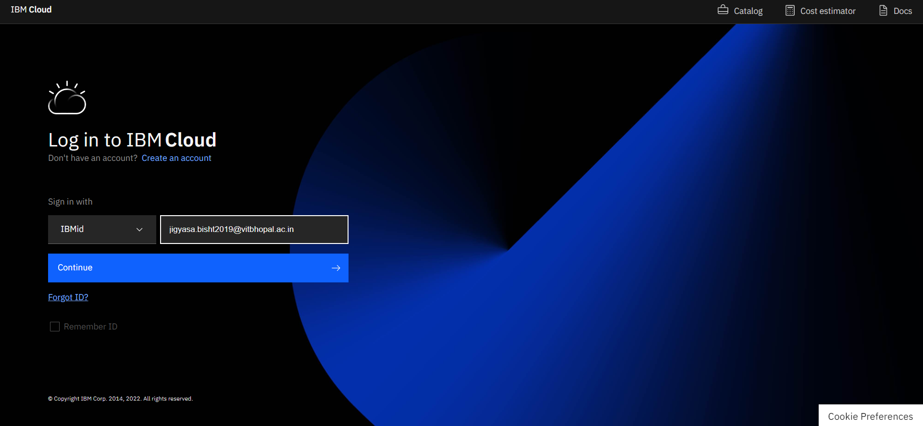

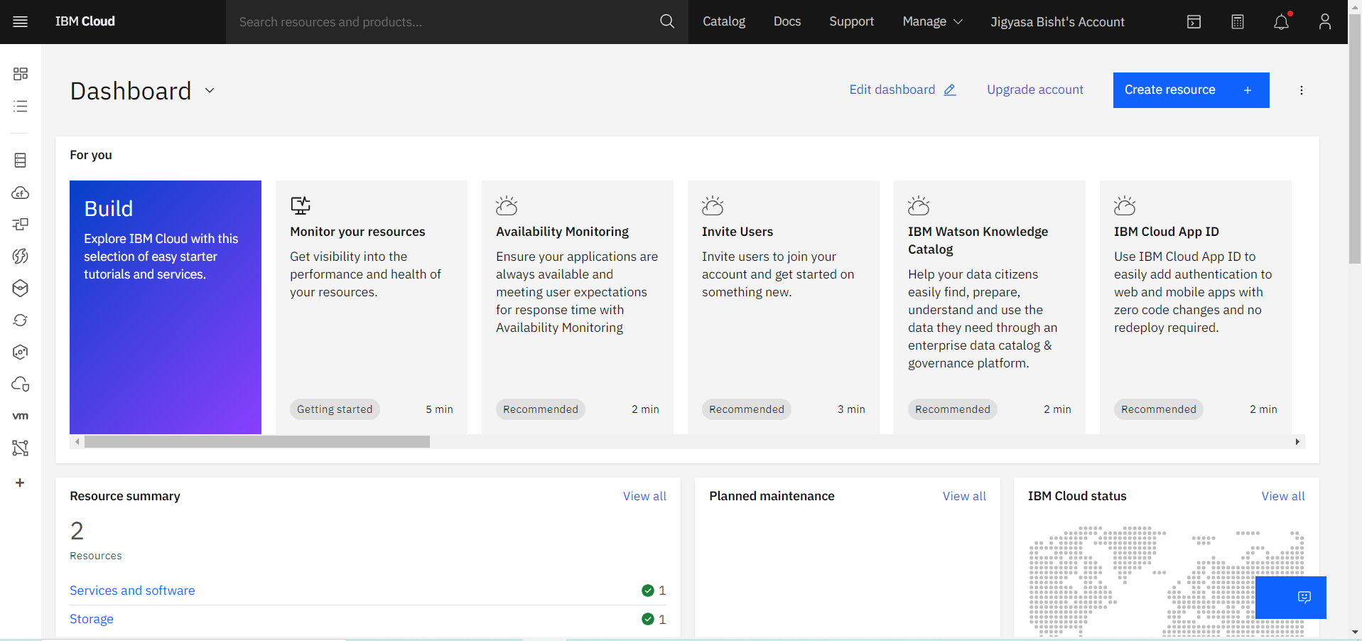

**>> Loading the Dataset**

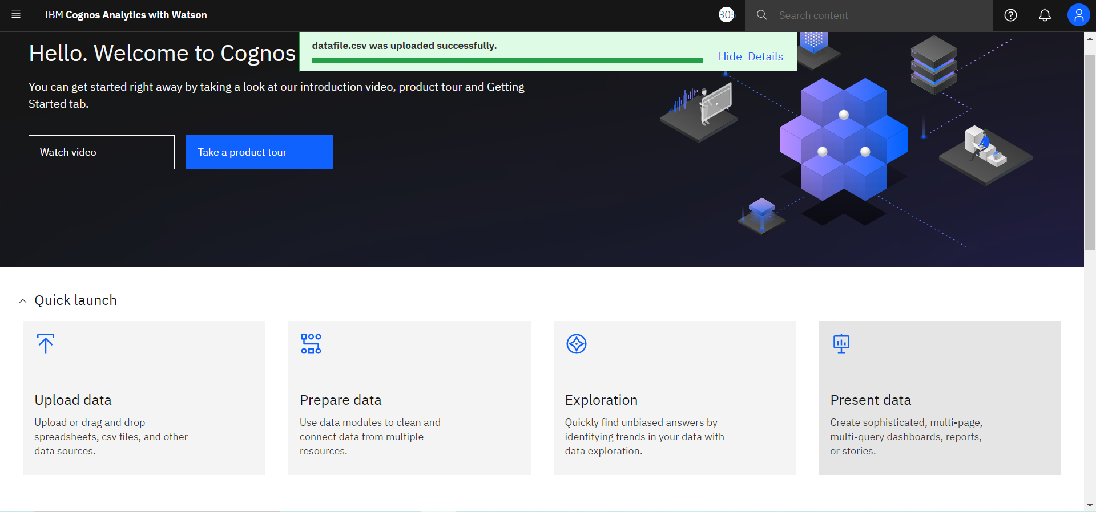

**>> Prepare the Dataset**

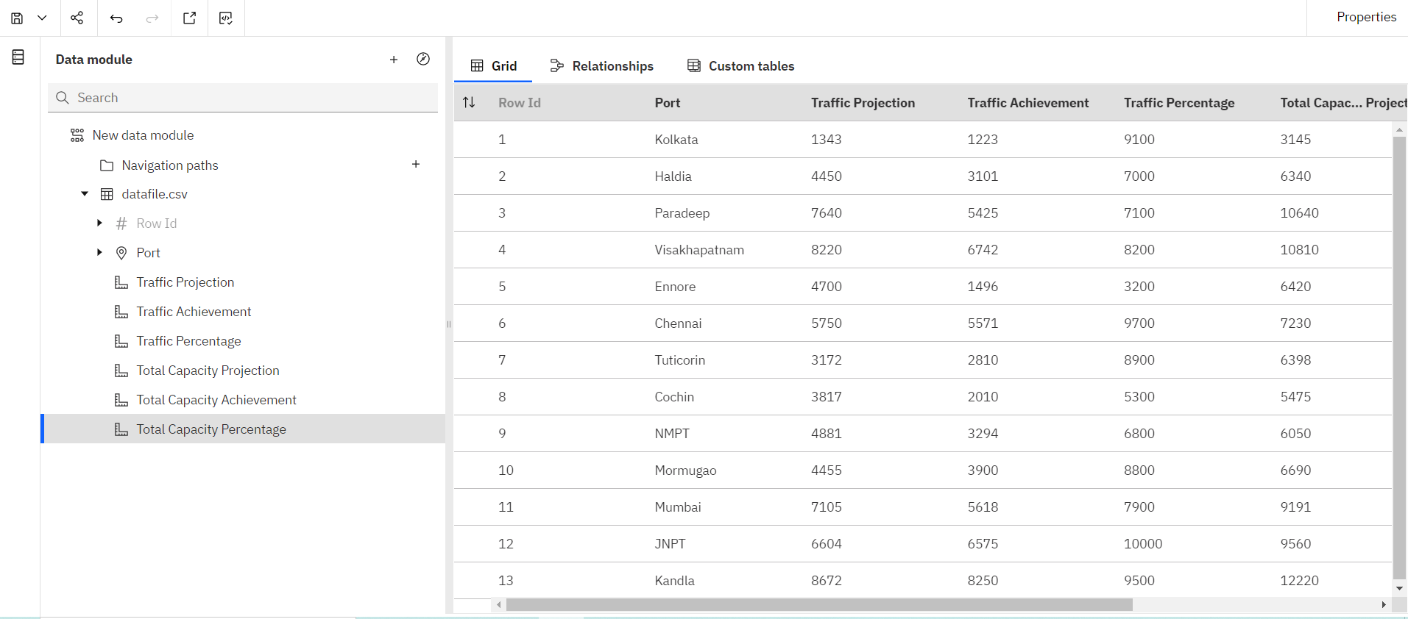

**>> Prepare Calculations**

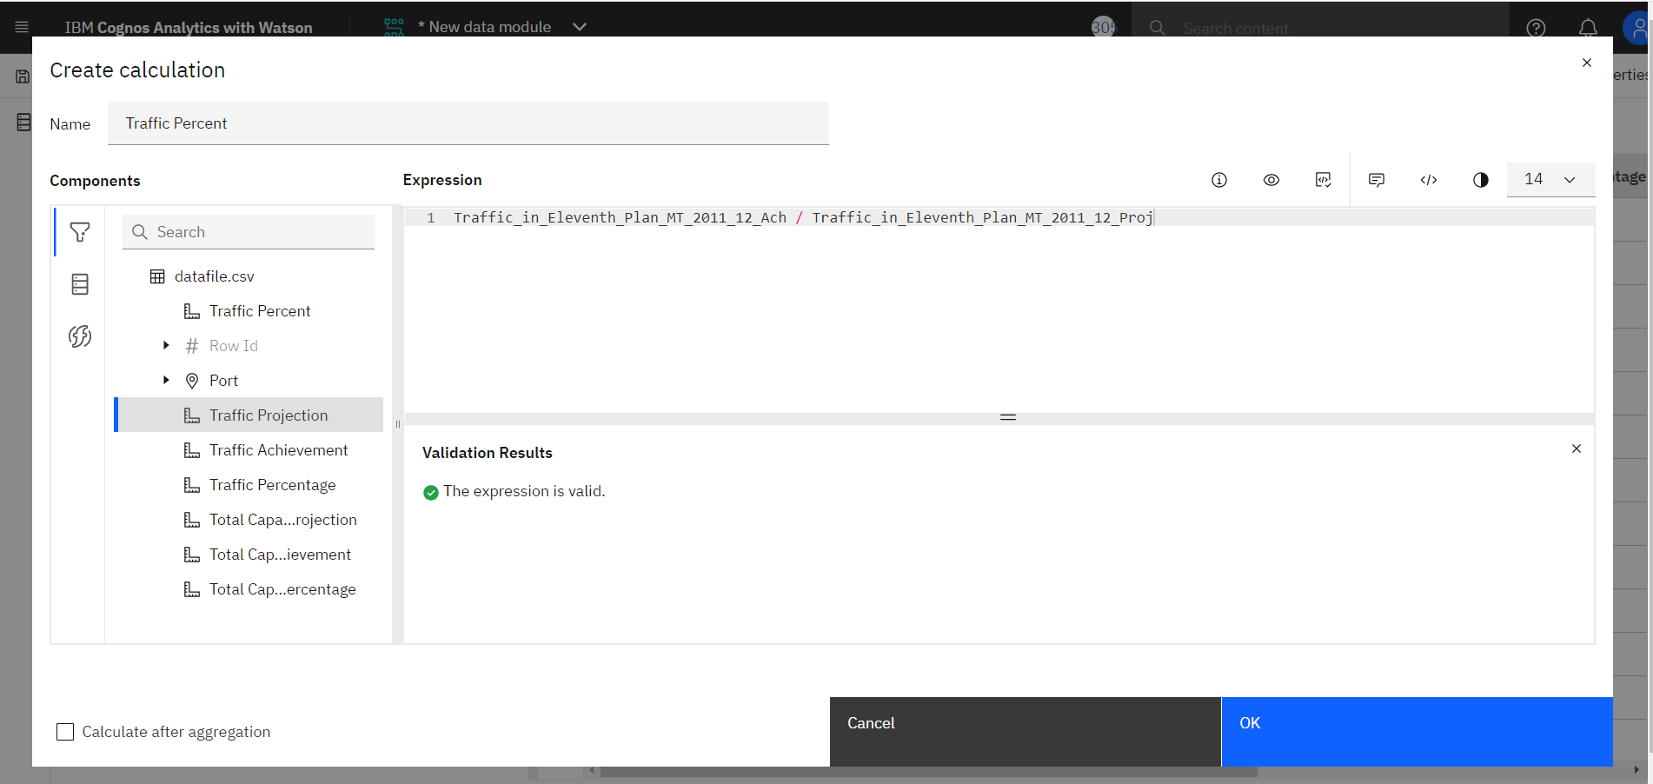

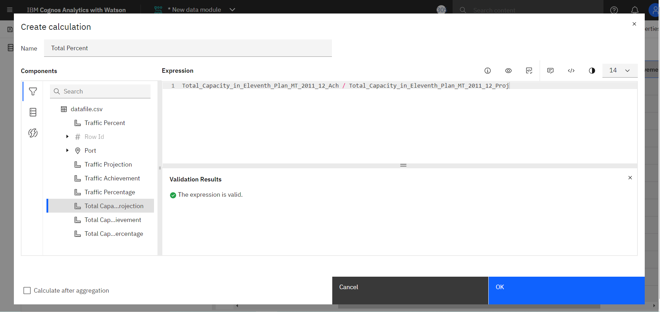

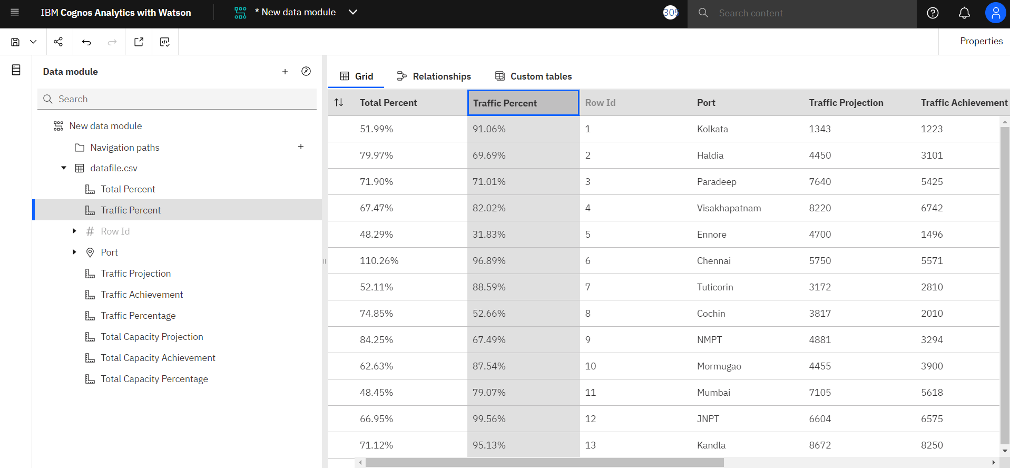

**>> Data Visualization Charts**

**Port Wise Traffic Distribution, Port Wise Capacity Distribution**

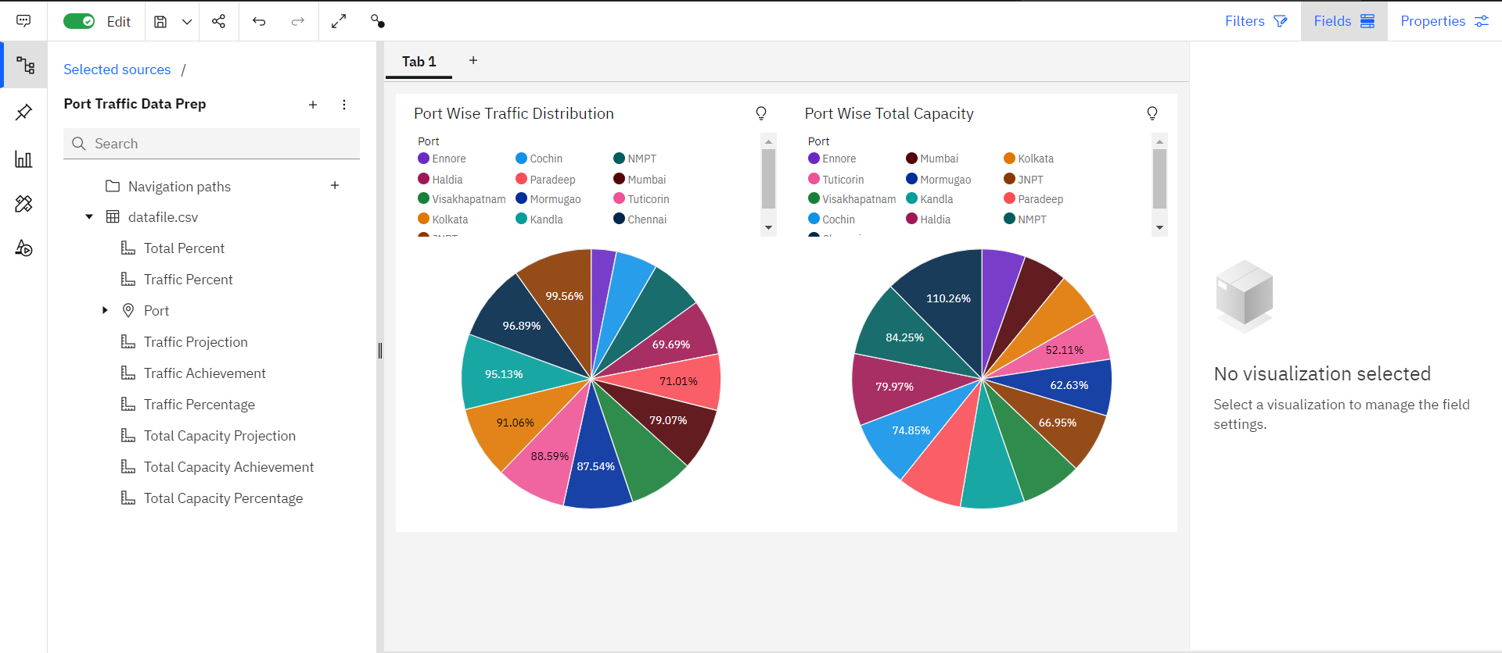

**Port Wise Traffic vs Capacity by Line Chart**

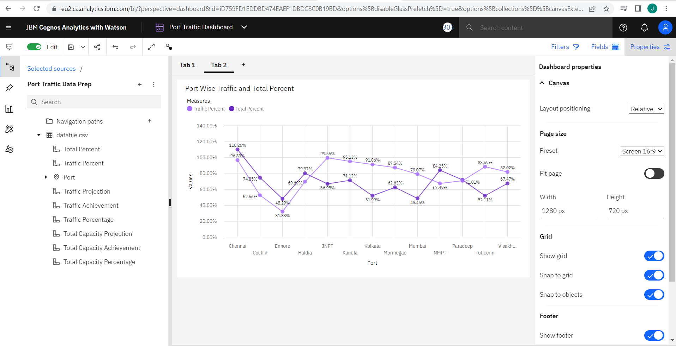

**Port WiseTraffic Projected vs Achieved by Column Chart**

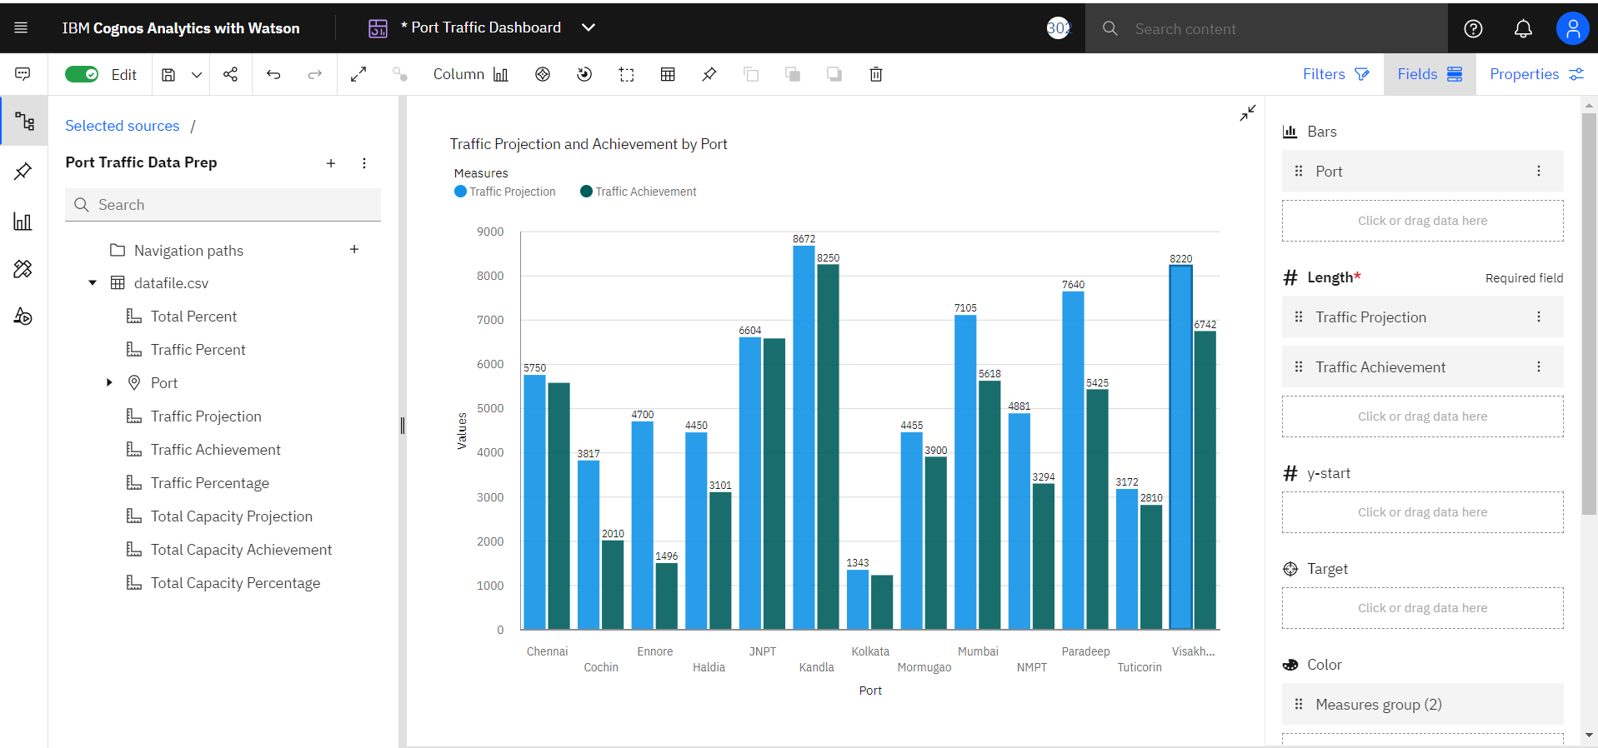

**Port WiseTraffic Projected vs Achieved by Stacked Column Chart**

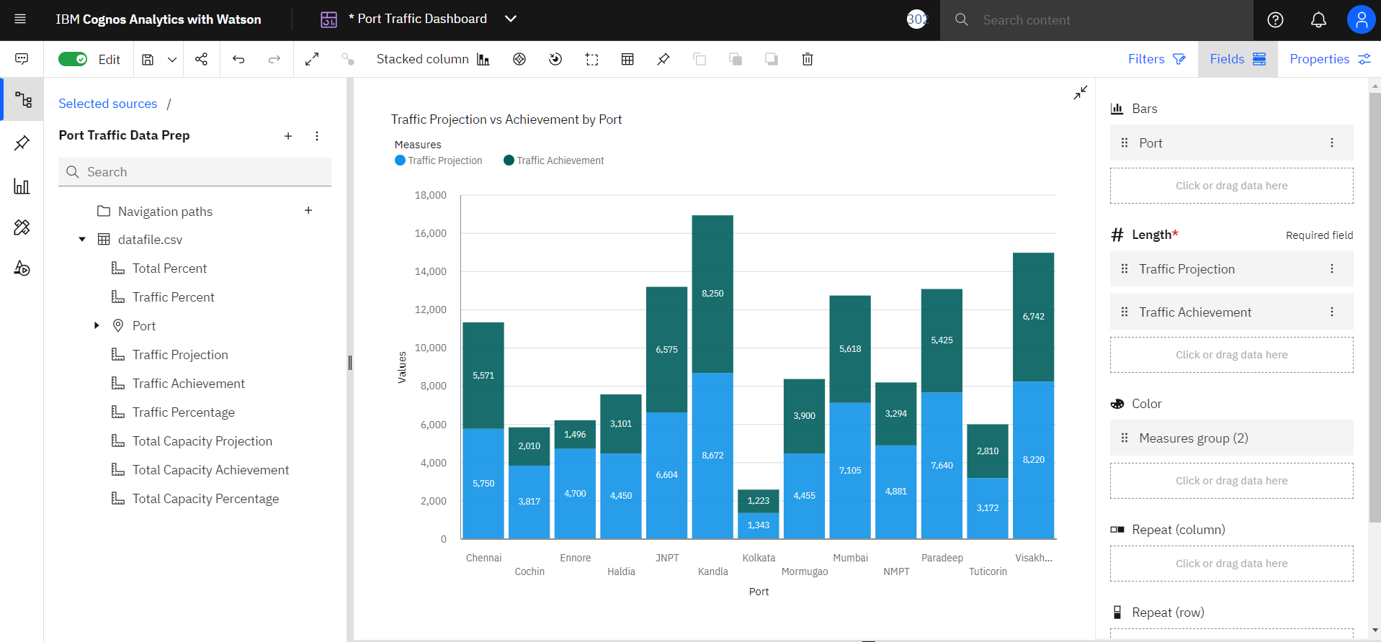

**Port Wise Total Capacity Projects vs Total Capacity Achieved by Line and Bar Chart**

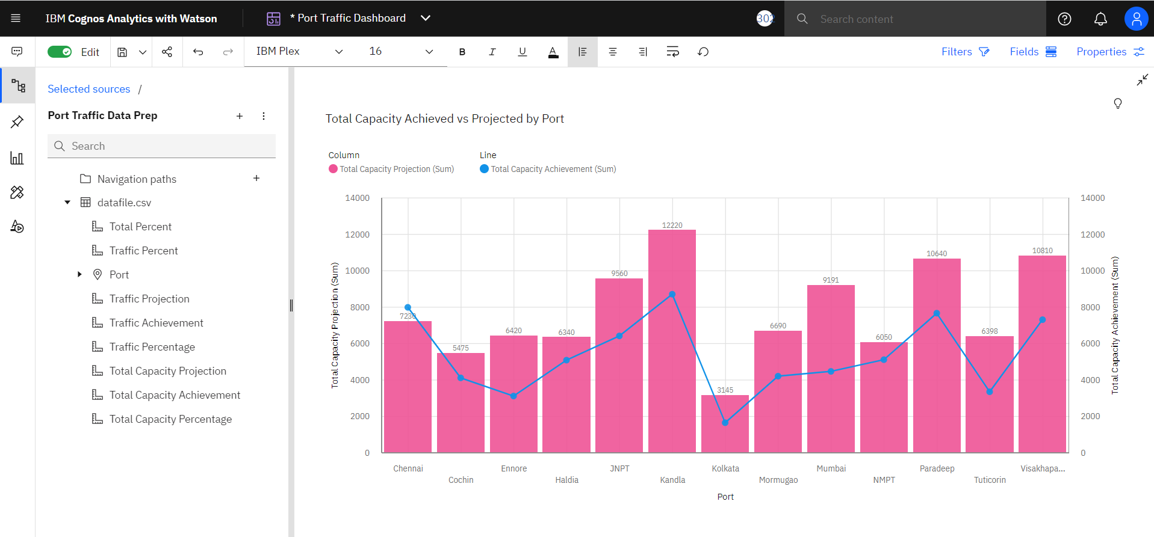

**Port Wise Traffic Projects vs Total Projected by Area Chart**

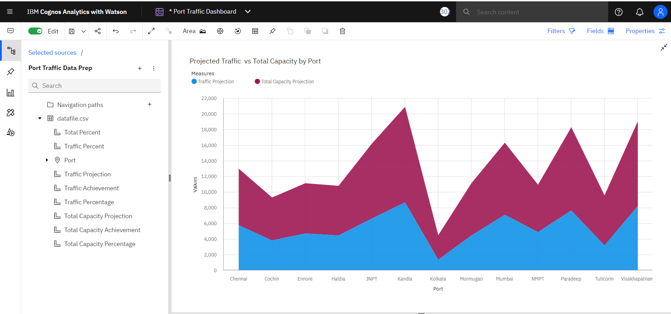

**Port Wise Total Capacity Achieve, Traffic Achieved using Stacked Bar**

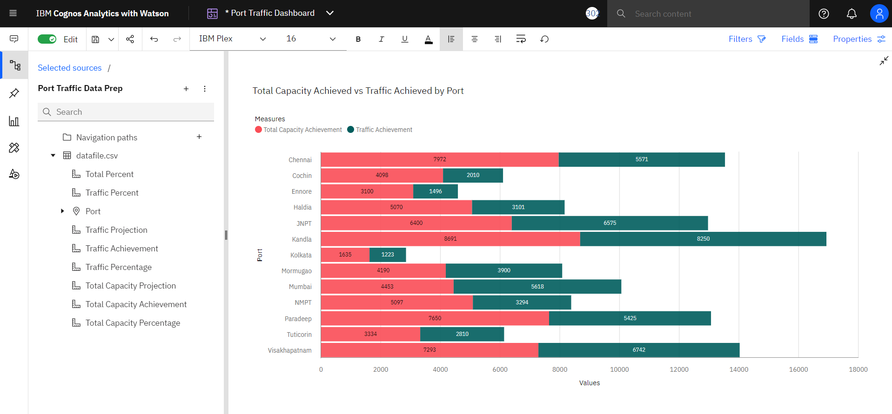

**Filters**

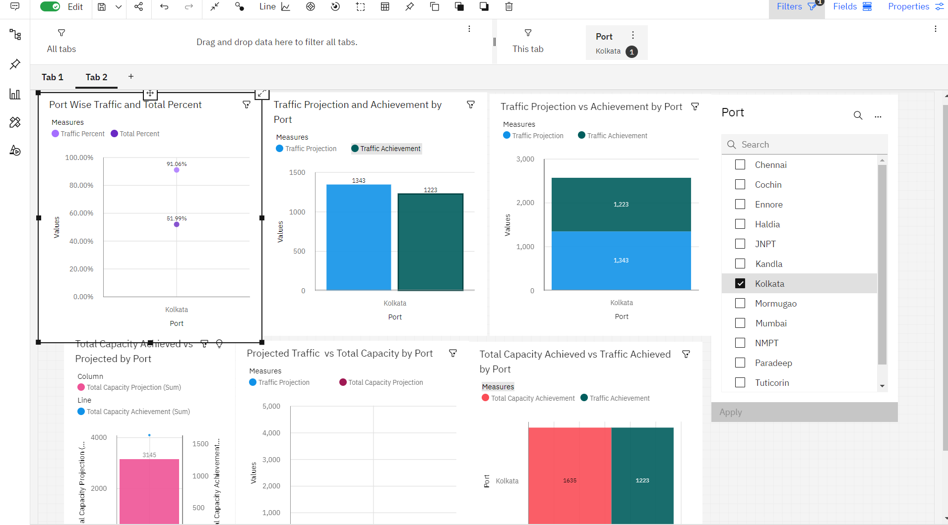

**Port Wise Total Capacity Achieved Using Map**

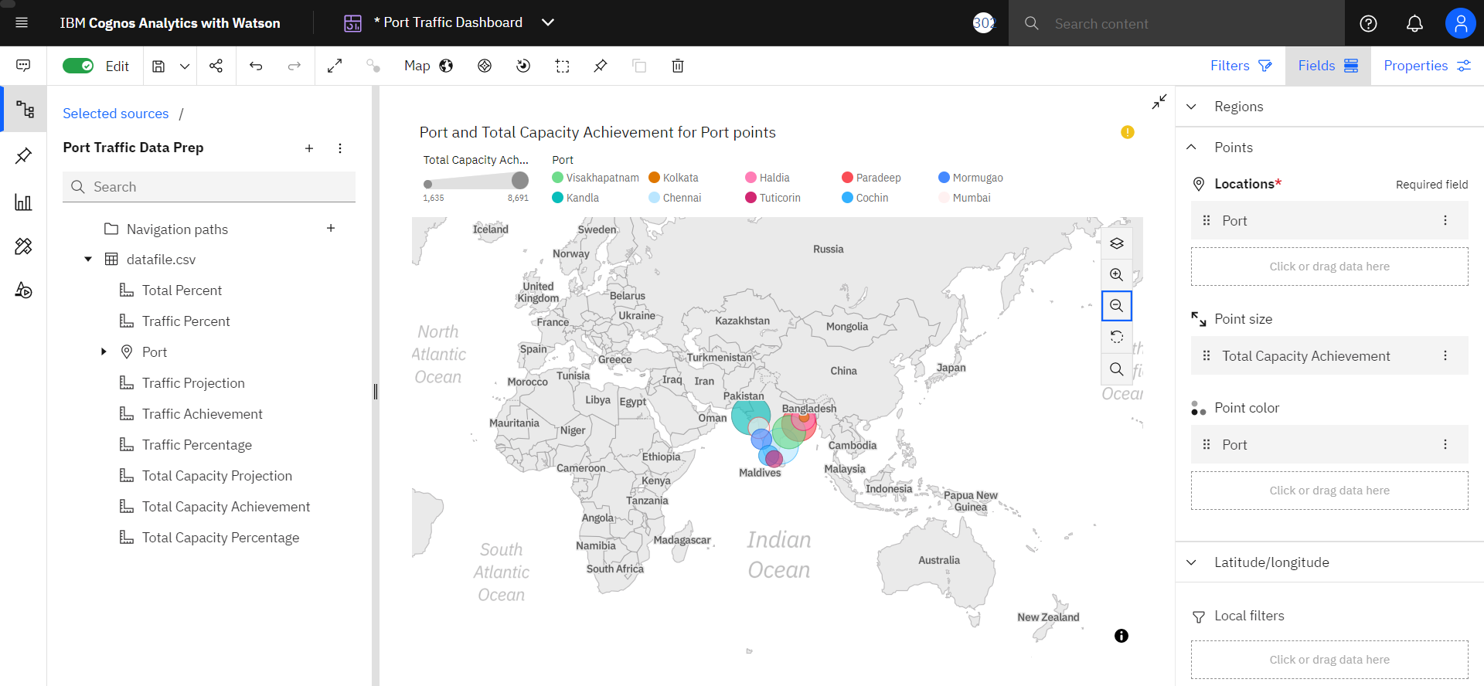

**Summary Cards and visual using Total Capacity vs Actual Capacity Column Chart**

